Code QA – Group 1 assures that all the Classes, atrtibutes, and operators are representative to the class diagram. 4/22/2020

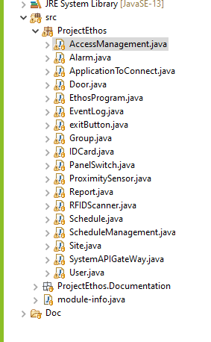

|  |
| --- |
| **Class Review** |
| Access Management - Good |
| Alarm – Good |
| ApptoConnect – Good |
| Door – Good |
| Ethos - Good |
| EventLog – Good |
| exitButton - Good |
| Group – Good |
| ID Card – Good |
| Panel Switch -Good |
| ProximitySensor – Good |
| Report – Good |
| RFIDScanner – Good |
| Schedule – Good |
| ScheduleManagement – Good |
| Site – Good |
| SystemAPIGateway – Good |
| User - Good |